HOSPITAL MANAGEMENT



COURT ROAD NETWORKZ SYSTEMS NAGERCOIL, KANYAKUMARI

STUDENT NAME :M.ESAKKI VEL RAJA

STUDENT ID : NSNCV0823133 STAFF NAME : ANTONET REETA COURSE NAME : CCNA

DATE : 04-10-2023

TABLE OF CONTENT

|  |  |  |
| --- | --- | --- |
| Serial.No | TITTLE | Page.No |
| 1 | Abstract | 1 |
| 2 | Acknowledgment |  |
| 3 | Introduction |  |
| 4 | Network Requirement |  |
| 5 | Hardware & software requirement |  |
| 6 | Switch & router Configuration |  |
| 7 | Network Topology |  |
| 8 | Output Results |  |
| 9 | Conclusion |  |

**Abstract**

The Primary purpose of a computer network is to share resources. A computer network is referred to as client/server if (at least) one of the computers is used to server other computer referred to as client. Beside the computers,other types of devices can be part of the network. In the early day of networking there will be once central server that contains the data and all the clients can access this data through a Network Interface card. Later on client server architecture came into existence, where still burden is there on the server machine. To avoid the disadvantages in distributed computing was introduced which reduce the burden on the server by providing work sharing capabilities. This paper describes how the concept of distributed computing came into existence based on the advantages and disadvantages that raised in earlier networking concepts. The concepts of distributed computing speaks that once data is available within the server (s), it should be able to be accessed and processed from any kind of client device like computer, computer, mobile phone, PDA, etc.

# ACKNOWLEDGMENT

First we would like to thank the Almighty for his wonderful presence with us throughtout the completion of the project and making it as a successful one.

We are expressing our deep gratitude to **COURT ROAD NETWORKZ SYSTEMS INSTITUTION**

which provided us an opportunity in fulfilling our most cherished desire in reaching our goal.

This is a great pleasure to express our deep sense of gratitude and thanks to our guide **MISS ANTONET REETA** for her valuable ideas, instantaneous help, effective support and continued encouragement which enabled for the successful completion of the project

W e g r a t e f u l l y r e m e m b e r t h e a v a i l a b l e suggestion of our respective staff for their valuable and timely guidance for the completion of the project.

W e g r a t e f u l l y r e m e m b e r t h e a v a i l a b l e suggestion of our respective staff for their valuable and timely guidance for the completion of this project. Finally we would like to express our sincere thanks to all our friends who gave good ideas not suggestions for our project.

# INTRODUCTION

Networking is referred as connecting computers electrically for the purpose of sharing i n f o r m a t i o n . R e s o u r c e s s u c h a s a f i l e , application, printer & software. The advantage of networking can be seen in the terms of security, efficiency, manageablility and cost as it allows collaboration between user in a wide range. The switches and router this device that play and important role in data transfer from one place to another using different technology such ad radio waves & wire.

# Networking Requirement

1. The active networking components (Routers, Switches, Wireless access points etc) with quantity.
2. The IP network design for each department.
3. Dynamic IP addressing design for all networks
4. Identify the configuration and features, wherever appropriate, which is required on the active components to setup the network.
5. Analysis, identification and explantion of methodologies to use for access restriction and internet sharing.
6. Creating and mapping IP networks with vlans.

# HARDWARE REǪUIREMENT

* Processor AMD PRO A4-4350B R4,5 COMPUTE

CORES 2C

+3G 2.50GHz

* RAM 4.00 GB
* System Type 64-bit operating system

# REǪUIREMENT

1. The following use cisco packet tracer to design and implement the network solution
2. Use OSPF as the routing protocol
3. Configure SSH in three routers.
4. Doctor room, Reception room, Medicine and Emergency room required to have a wireless network for the users
5. Floor 1 and Floor 2 and Ground floor have different vlan
6. Class A,C type IP address used in every department
7. Floor 1 and Floor 2 are connected in Inter-Vlan.
8. Devices in Server Room are allocated IP address statically
9. Syslog is implemented in three routers.
10. Test communication ensure everything configured is working as expected

# SOFTWARE REǪUIREMENT

* CISCO Packet Tracer

# ROUTER CONFIGURATION

ROUTER 1

ip dhcp pool EMERGENCY-WARD

network 60.0.0.0 255.0.0.0

default-router 60.0.0.1

dns-server 80.0.0.3

ip dhcp pool CANTEEN

network 70.0.0.0 255.0.0.0

default-router 70.0.0.1

dns-server 80.0.0.3

ip dhcp pool SERVER-ROOM

network 80.0.0.0 255.0.0.0

default-router 80.0.0.1

dns-server 80.0.0.3

ip domain-name hospital

spanning-tree mode pvst

interface GigabitEthernet0/0

no ip address

ip access-group 1 in

duplex auto

speed auto

interface GigabitEthernet0/0.60

encapsulation dot1Q 60

ip address 60.0.0.1 255.0.0.0

interface GigabitEthernet0/0.70

encapsulation dot1Q 70

ip address 70.0.0.1 255.0.0.0

interface GigabitEthernet0/1

ip address 80.0.0.1 255.0.0.0

ip access-group 1 out

duplex auto

speed auto

!

interface Serial0/1/0

ip address 192.168.1.1 255.255.255.0

clock rate 64000

!

interface Serial0/1/1

ip address 192.168.2.1 255.255.255.0

clock rate 64000

!

interface Vlan1

no ip address

shutdown

!

router ospf 1

log-adjacency-changes

network 192.168.1.0 0.0.0.255 area 1

network 192.168.2.0 0.0.0.255 area 1

network 60.0.0.0 0.0.0.255 area 1

network 70.0.0.0 0.0.0.255 area 1

network 80.0.0.0 0.255.255.255 area 1

!

ip classless

!

ip flow-export version 9

!

!

access-list 120 deny tcp host 60.0.0.2 host 80.0.0.3 eq ftp

access-list 120 permit ip any any

access-list 1 deny host 60.0.0.2

access-list 1 permit any

!

!

!

!

!

!

logging 80.0.0.3

line con 0

!

line aux 0

!

line vty 0 4

password 1234

login

transport input ssh

line vty 5 15

password 1234

login

transport input ssh

!

!

end

ROUTER 2

hostname F2-ROUTER

enable secret 5 $1$mERr$vTbHul1N28cEp8lkLqr0f/

enable password cisco

ip dhcp pool DOCTOR

network 40.0.0.0 255.0.0.0

default-router 40.0.0.1

dns-server 80.0.0.3

ip dhcp pool PHYSIO

network 50.0.0.0 255.0.0.0

default-router 50.0.0.1

dns-server 80.0.0.3

username f2 password 0 1234

ip domain-name hospital

spanning-tree mode pvst

interface GigabitEthernet0/0

no ip address

ip access-group 120 in

duplex auto

speed auto

interface GigabitEthernet0/0.40

encapsulation dot1Q 40

ip address 40.0.0.1 255.0.0.0

interface GigabitEthernet0/0.50

encapsulation dot1Q 50

ip address 50.0.0.1 255.0.0.0

interface GigabitEthernet0/1

no ip address

duplex auto

speed auto

shutdown

interface Serial0/1/0

ip address 192.168.1.2 255.255.255.0

ip access-group 120 out

interface Serial0/1/1

ip address 192.168.3.2 255.255.255.0

interface Vlan1

no ip address

shutdown

router ospf 1

log-adjacency-changes

network 192.168.1.0 0.0.0.255 area 1

network 192.168.3.0 0.0.0.255 area 1

network 40.0.0.0 0.255.255.255 area 1

network 50.0.0.0 0.255.255.255 area 1

!

ip classless

!

ip flow-export version 9

!

!

access-list 120 deny tcp host 50.0.0.3 host 80.0.0.3 eq ftp

access-list 120 permit ip any any

logging 80.0.0.3

line con 0

!

line aux 0

!

line vty 0 4

password 1234

login

transport input ssh

line vty 5 15

password 1234

login

transport input ssh

!

!

!

end

ROUTER 2

hostname F1-ROUTER

enable secret 5 $1$mERr$vTbHul1N28cEp8lkLqr0f/

enable password cisco

ip dhcp pool RECEPTION

network 10.0.0.0 255.0.0.0

default-router 10.0.0.1

dns-server 80.0.0.3

ip dhcp pool BILL-COUNTER

network 20.0.0.0 255.0.0.0

default-router 20.0.0.1

dns-server 80.0.0.3

ip dhcp pool MEDICINE

network 30.0.0.0 255.0.0.0

default-router 30.0.0.1

dns-server 80.0.0.3

username f1 password 0 1234

ip domain-name hospital

spanning-tree mode pvst

interface GigabitEthernet0/0

no ip address

ip access-group 120 in

duplex auto

speed auto

!

interface GigabitEthernet0/0.10

encapsulation dot1Q 10

ip address 10.0.0.1 255.0.0.0

ip access-group 120 in

!

interface GigabitEthernet0/0.20

encapsulation dot1Q 20

ip address 20.0.0.1 255.0.0.0

!

interface GigabitEthernet0/0.30

encapsulation dot1Q 30

ip address 30.0.0.1 255.0.0.0

!

interface GigabitEthernet0/1

no ip address

duplex auto

speed auto

shutdown

!

interface Serial0/1/0

ip address 192.168.2.2 255.255.255.0

ip access-group 120 out

!

interface Serial0/1/1

ip address 192.168.3.1 255.255.255.0

clock rate 64000

!

interface Vlan1

no ip address

shutdown

!

router ospf 1

log-adjacency-changes

network 192.168.2.0 0.0.0.255 area 1

network 192.168.3.0 0.0.0.255 area 1

network 10.0.0.0 0.255.255.255 area 1

network 20.0.0.0 0.255.255.255 area 1

network 30.0.0.0 0.255.255.255 area 1

access-list 120 deny tcp host 10.0.0.5 host 80.0.0.3 eq www

access-list 120 permit ip any any

logging 80.0.0.3

line con 0

!

line aux 0

!

line vty 0 4

password 1234

login

transport input ssh

line vty 5 15

password 1234

login

transport input ssh

!

!

!

end

# SWITCH CONFIGURATION

The following configuration details the actual setup to performed on a CISCO switch.

Create VLAN’ s, VLAN 10 to VLAN 70 with respective names on switch

FLOOR 1 SWITCH

hostname F1-SW

enable password cisco

spanning-tree mode pvst

spanning-tree extend system-id

!

interface FastEthernet0/1

switchport mode trunk

!

interface FastEthernet0/2

switchport access vlan 10

switchport mode access

switchport port-security

switchport port-security mac-address sticky

switchport port-security mac-address sticky 0090.0C40.1090

!

interface FastEthernet0/3

switchport access vlan 10

switchport mode access

switchport port-security

switchport port-security mac-address sticky

switchport port-security mac-address sticky 0060.3E8E.4842

!

interface FastEthernet0/4

switchport access vlan 10

switchport mode access

switchport port-security mac-address sticky

switchport port-security mac-address sticky 00E0.A37E.7AA9

!

interface FastEthernet0/5

switchport access vlan 10

switchport mode access

switchport port-security

switchport port-security mac-address sticky

switchport port-security mac-address sticky 0060.4727.6956

!

interface FastEthernet0/6

switchport access vlan 20

switchport mode access

switchport port-security

switchport port-security mac-address sticky

switchport port-security mac-address sticky 0001.96B7.4390

!

interface FastEthernet0/7

switchport access vlan 20

switchport mode access

switchport port-security

switchport port-security mac-address sticky

switchport port-security mac-address sticky 0001.9694.0A39

!

interface FastEthernet0/8

switchport access vlan 20

switchport mode access

switchport port-security

switchport port-security mac-address sticky

switchport port-security mac-address sticky 0002.1606.0779

!

interface FastEthernet0/9

switchport access vlan 30

switchport mode access

switchport port-security

switchport port-security mac-address sticky

switchport port-security mac-address sticky 00E0.B077.084E

!

interface FastEthernet0/10

switchport access vlan 30

switchport mode access

switchport port-security mac-address sticky

switchport port-security mac-address sticky 0002.1789.E187

!

interface FastEthernet0/11

switchport access vlan 30

switchport mode access

switchport port-security

switchport port-security mac-address sticky

switchport port-security mac-address sticky 0060.70C5.4776

interface Vlan1

no ip address

shutdown

line con 0

line vty 0 4

login

line vty 5 15

Login

End

FLOOR 2 SWITCH

hostname F2-SW

enable password cisco

interface FastEthernet0/1

switchport access vlan 40

switchport mode access

switchport port-security mac-address sticky

switchport port-security mac-address sticky 00D0.97C6.087C

interface FastEthernet0/2

switchport mode trunk

interface FastEthernet0/3

switchport access vlan 50

switchport mode access

switchport port-security

switchport port-security mac-address sticky

switchport port-security mac-address sticky 0090.0C21.47C9

interface FastEthernet0/4

switchport access vlan 50

switchport mode access

switchport port-security

switchport port-security mac-address sticky

switchport port-security mac-address sticky 0001.C9DD.A114

interface FastEthernet0/5

switchport access vlan 50

switchport mode access

switchport port-security

switchport port-security mac-address sticky

switchport port-security mac-address sticky 0002.17A4.752B

interface FastEthernet0/6

switchport access vlan 50

switchport mode access

switchport port-security

switchport port-security mac-address sticky

switchport port-security mac-address sticky 000C.CF5B.ABCD

End

GR SWITCH

hostname GR-SW

!

enable password cisco

!

!

!

!

!

!

spanning-tree mode pvst

spanning-tree extend system-id

!

interface FastEthernet0/1

switchport mode trunk

!

interface FastEthernet0/2

switchport access vlan 60

switchport mode access

switchport port-security

switchport port-security mac-address sticky

switchport port-security mac-address sticky 00E0.F950.990A

!

interface FastEthernet0/3

switchport access vlan 60

switchport mode access

switchport port-security

switchport port-security mac-address sticky

switchport port-security mac-address sticky 0000.0C30.8B11

!

interface FastEthernet0/4

switchport access vlan 60

switchport mode access

switchport port-security mac-address sticky

switchport port-security mac-address sticky 0060.47AA.2AD8

interface FastEthernet0/5

switchport access vlan 70

switchport mode access

switchport port-security

switchport port-security mac-address sticky

switchport port-security mac-address sticky 0090.2B65.16A8

interface FastEthernet0/6

switchport access vlan 70

switchport mode access

switchport port-security

switchport port-security mac-address sticky

switchport port-security mac-address sticky 0030.A35A.B38D

interface FastEthernet0/7

switchport access vlan 70

switchport mode access

switchport port-security

switchport port-security mac-address sticky

switchport port-security mac-address sticky 0003.E4BA.7C8A

interface FastEthernet0/8

switchport access vlan 70

switchport mode access

switchport port-security mac-address sticky

switchport port-security mac-address sticky 00E0.B038.BE64

GR2 SWITCH

hostname GR2-SW

enable password cisco

interface FastEthernet0/1

switchport mode access

switchport port-security

switchport port-security mac-address sticky

switchport port-security mac-address sticky 0090.0C8A.ED12

interface FastEthernet0/2

switchport mode access

switchport port-security

switchport port-security mac-address sticky

switchport port-security mac-address sticky 00E0.F91E.A

End

# NETWORK TOPOLOGY

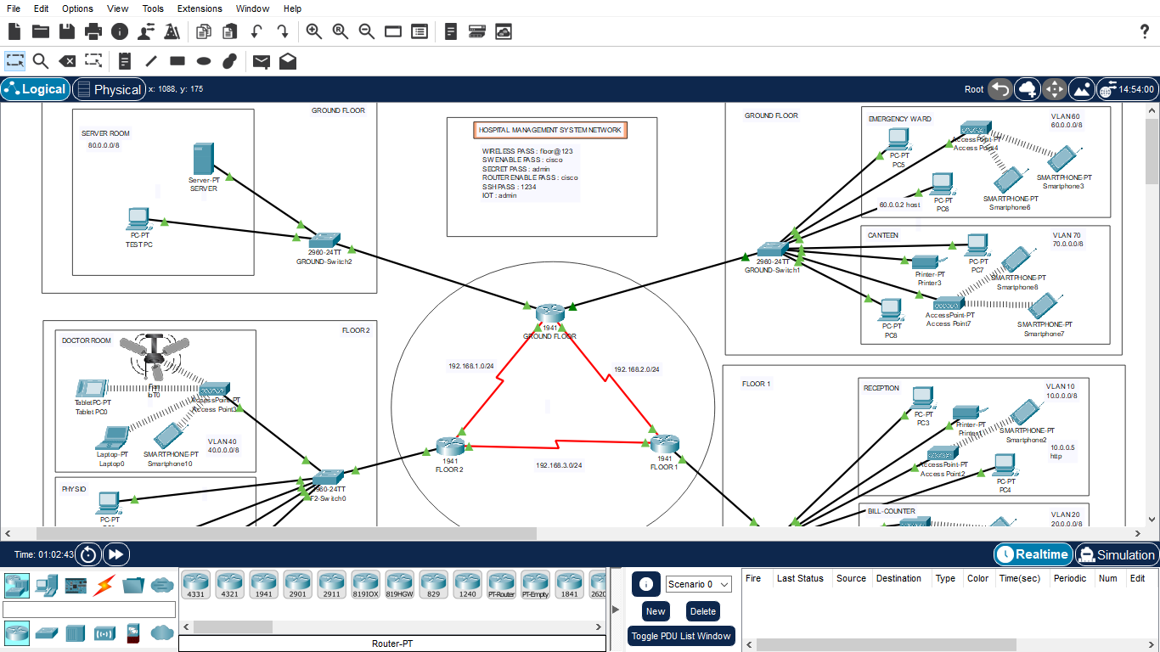

**INTERVLANS PING**

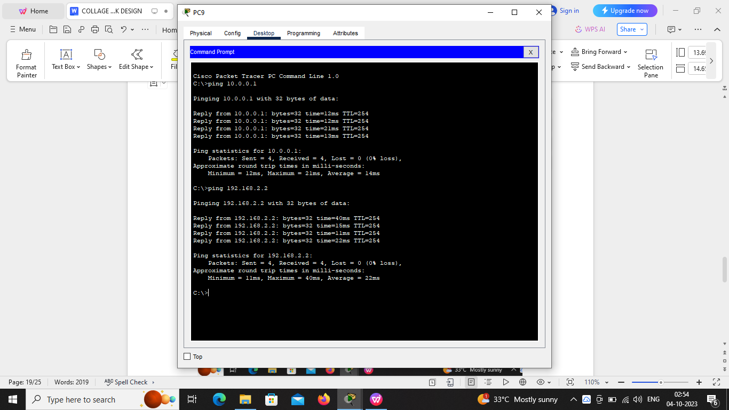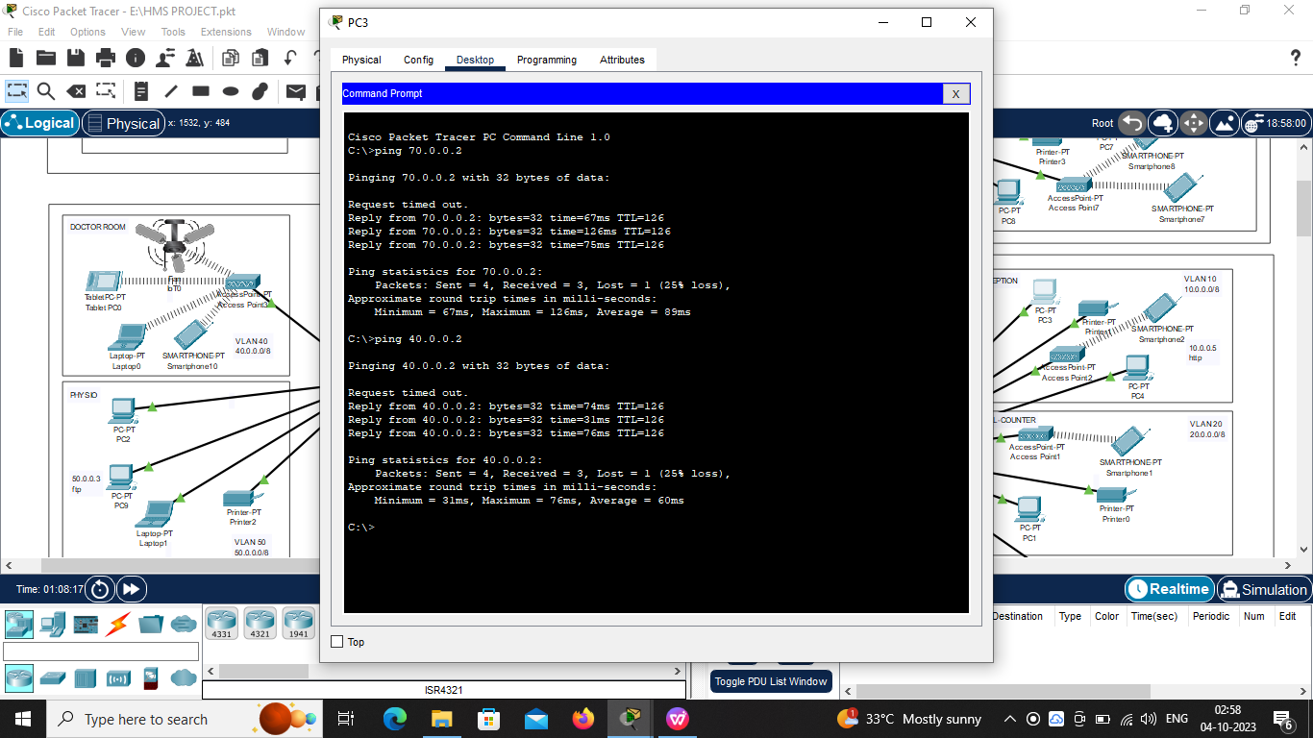

# SSH

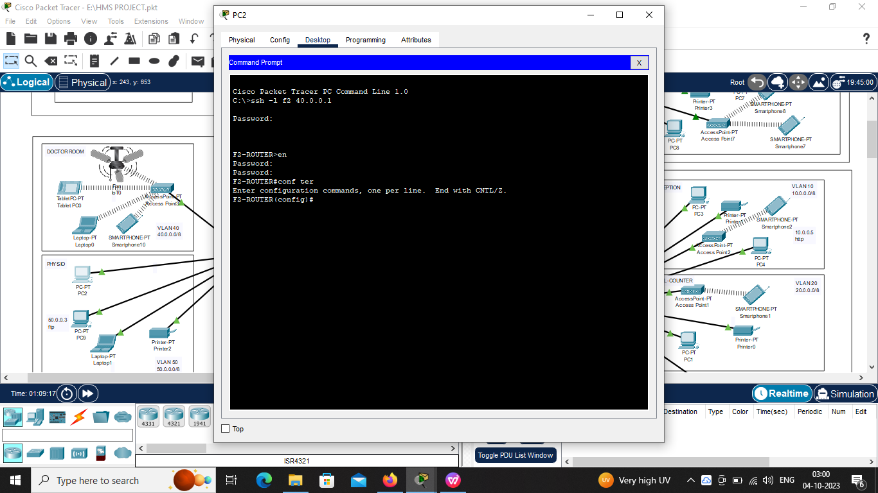

**IOT**

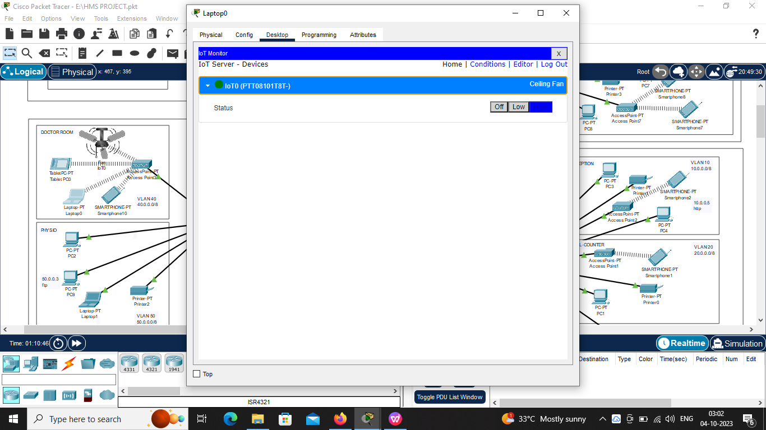

# SYSLOG

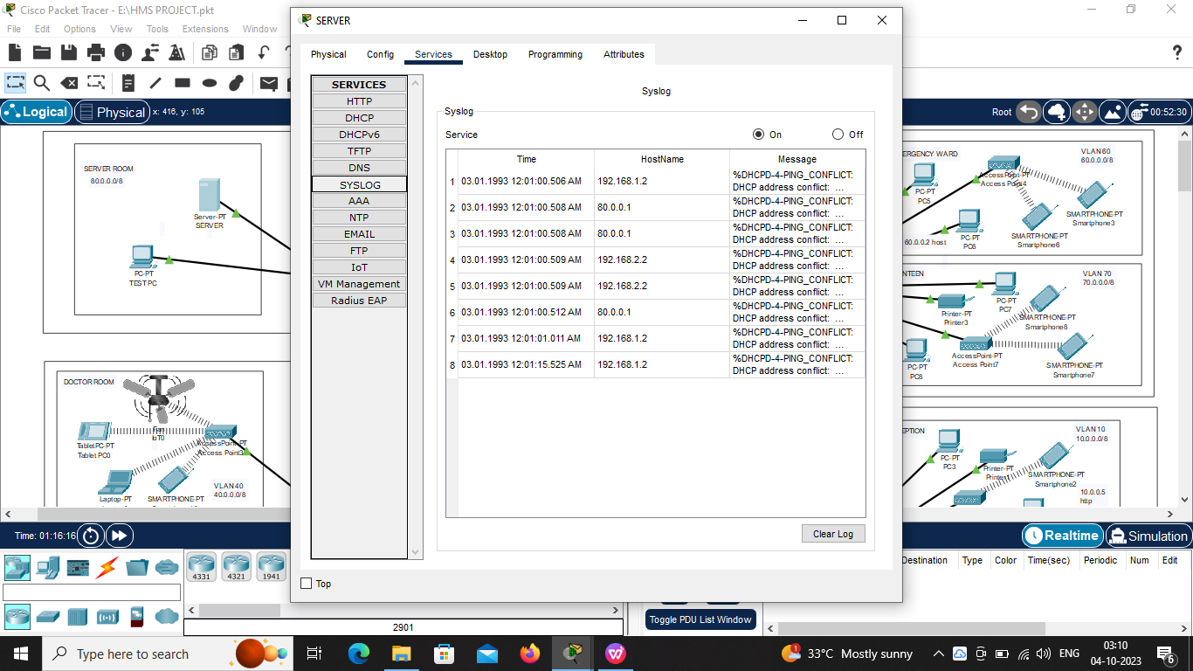

**HTTP**

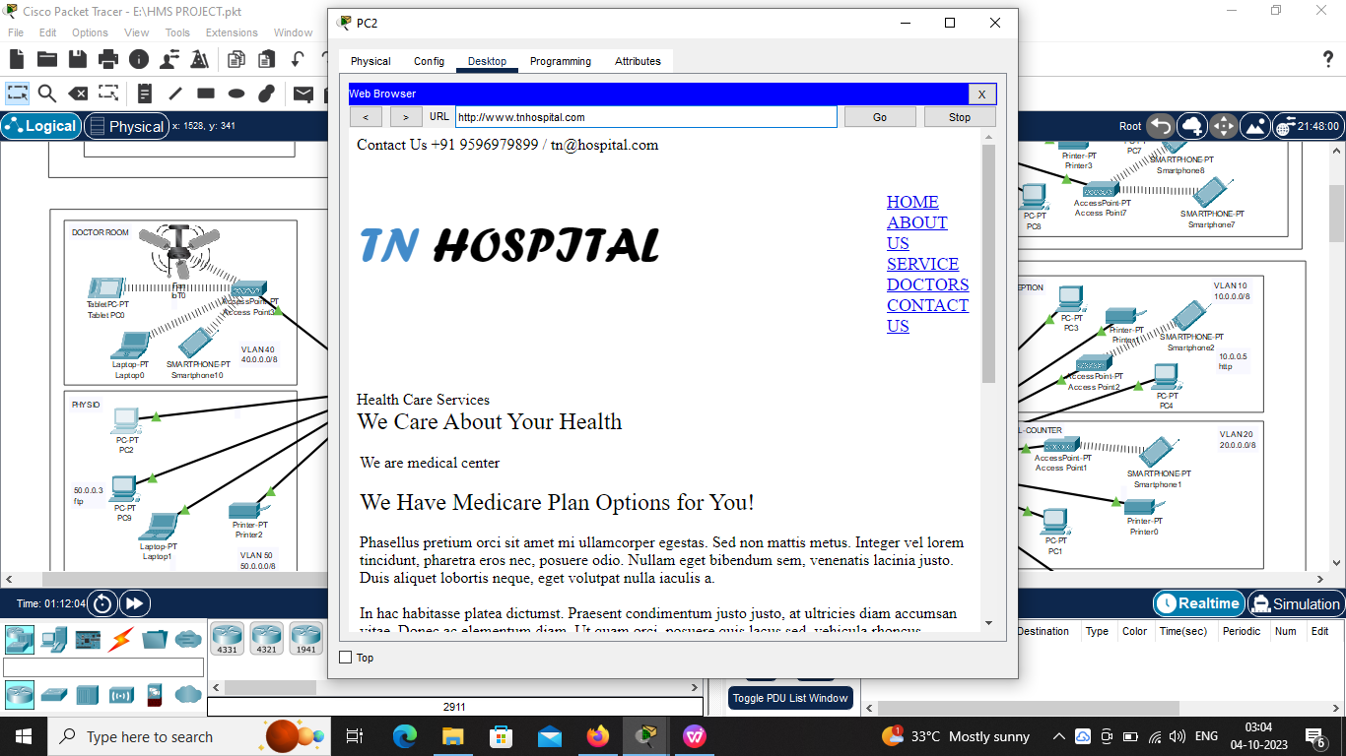

# WIRELESS ACCESSPOINT

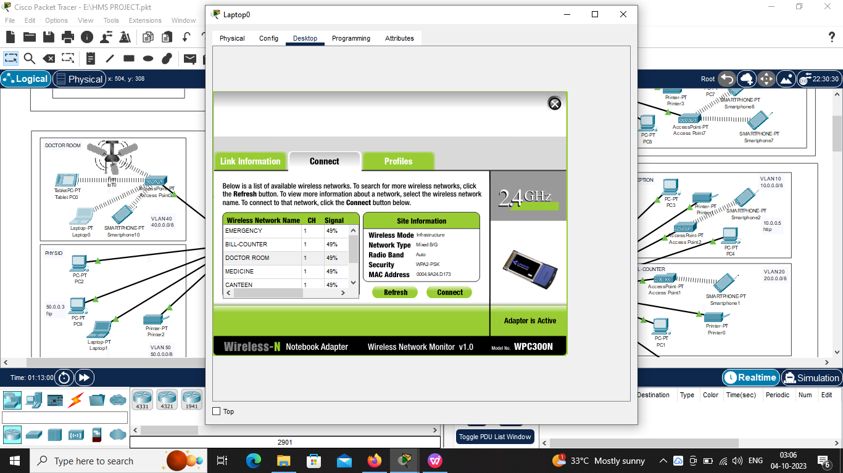

**CONCLUSION**

The whole network provide the convenient and secure way for the entire users of the Hospital and use better convenient way to access in order to get uninterrupted network, especially vlan & inter-vlan concept for the particular switches.